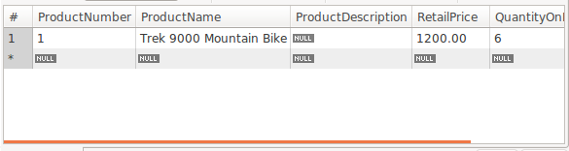

T1 starts with 6 quantities

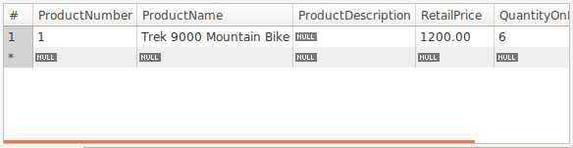

After running the UPDATE statement on T2, T1 still has 6 quantities.

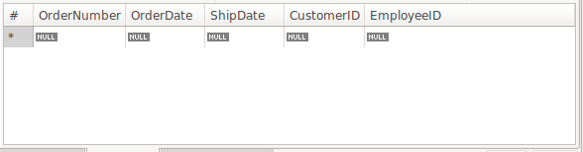

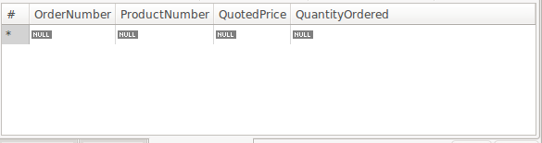

After running the two INSERT statements on T2, T1’S Order and Order_Details table remained empty.

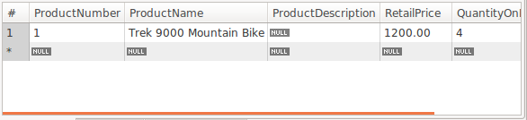

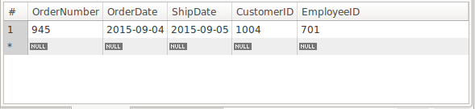

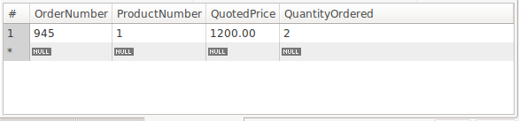

Copying and running three queries in T2 gave a different result. They were affected by the previous statements.

After committing T2

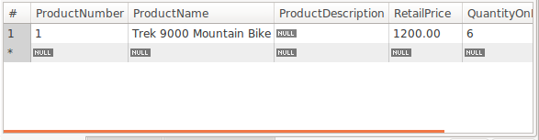

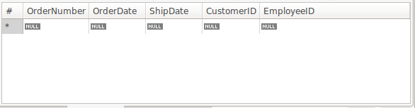

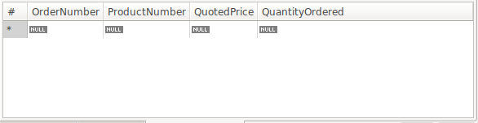

After committing T1

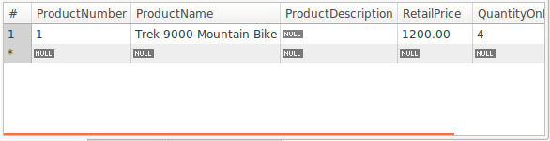

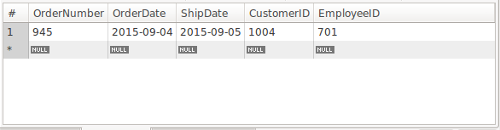

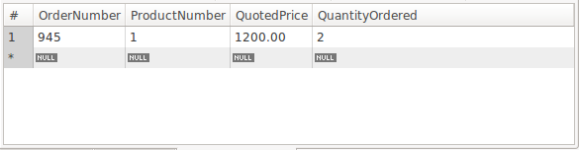

T1 and T2 are at the repeatable-read isolation level.

A transaction sees the changes after running commit. After running the transaction in T2, followed by the queries statements in T2, we could see that the changes had taken effect. However, running the queries in T1, showed that table was still the same as it was at the beginning. After running commit on T2 and T1, followed by running the queries on T1, the changes went through.

T1 can’t see changes of T2 when T2 commits

The repeatable-read isolation level guarantees that any data read cannot change. After committing T2, when T1 read the same data again, the previously read data was returned, unchanged. After running commit for T1, the data read has updated. We do have phantoms here in MySQL. Phantom read occurs when the same query returns a different result, due to an INSERT or DELETE statement in another transaction.